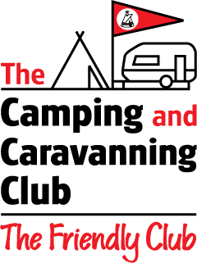
EASTERN REGION
Camping & Caravanning Club

“Eastern Region Extravaganza “

Stradsett Hall, Kings Lynn, Norfolk, PE 33 9HA
13th – 16th June 2024 (Booked Meet) Site Opens 10am

Name _______________________________Membership Number_______________
Address _________________________________________________ _____
______ _________________ ____
Contact Number __________________________ Email: __________________________________
Vehicle Registration Number ______________
MH | Caravan | Tent | Trailer Tent
Type of Unit: Approx Length: ____________________Metre’s
A weekend fee of £55 (if booked before 1st April) this is for a unit which includes 2 adults & children
under 18 years of age.
Additional adult members staying in the family unit will be charged an additional fee of
£5.00 per person per night.

No of Adults ______ No of children (under 18 yrs.) _________
CCY – Name and Membership number (Free of charge) _________________________________________

Extra Adult Name and Membership No (£5 per unit night) ________________________________________
 | Number required: | Total:
Weekend Fee - Three Nights - £65 |  | £
Weekend Fee - Two Nights - £55 |  | £
Extra Adults - £5 each per night |  | £
Early Bird discount (if booked and paid before 1St April) - £10.00 |  | -£10.00
Cream Teas - £3.50 each (Saturday afternoon) |  | £
Pork Rolls - £5 each (Saturday Evening) |  | £
Total Payable |  | £

Transfer Details Sort Code: 30-99-50 Account No: 22115660 (please quote surname as reference)
Account Name Camping & Caravanning Club – Eastern Region Transfer Date __________
OR
Cheque no ________ (Made Payable to Camping & Caravanning Club – Eastern Region)

Please complete the above details and forward to:
Michael Tidmarsh 10 Firmin Gardens, Thorrington, Colchester, CO7 8GJ
Email: treasurer.easternregion.ccc@gmail.com Telephone – 07770 917062

CLOSING DATE – Friday 31st May 2024

