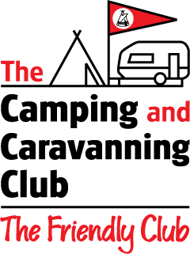
EASTERN REGION
Camping & Caravanning Club

“50th Birthday Celebrations Weekend”
White House Farm, Wortham, Diss, Norfolk. IP22 1PU
16th – 18th June 2023 (Booked Meet)
Site Opens at 9.00am

Name ________________________________________________________
Address ________________________________________________________
______ _____________________
Contact Number __________________________ Email ______________________
Vehicle Registration Number ________________________________________________________

Type of Unit Caravan* / Motorhome* / Tent* / Trailer Tent* /Folding Camper*. (*Delete as appropriate).
Approx. Length of Unit ________________

A weekend fee of £25.00, this is for a unit which includes 2 adults & all the children under 18 yrs of age.
Additional adult members staying in the family unit will be charged an additional fee of
£5.00 per person per night.

We will be providing a “Hog Roast” on Saturday – should you have any dietary requirements could you please advise accordingly – many thanks.

No of Adults ______ No of children (under 18 yrs) __________ DA / Section ________________

Membership No/s : ___________________________ Extra Adult Membership No _______________

Transfer Details Sort Code: 30-99-50 Account No : 22115660 (please quote surname as reference)
Account Name Camping & Caravanning Club – Eastern Region Transfer Date __________

OR

Cheque no ________ (with form payable to Camping & Caravanning Club – Eastern Region)

Please complete the above details and forward to the following :

Email address: lawalsh1955@gmail.com
Post: Linda Walsh
“Rowan” The Street,
Hepworth, DISS,
Norfolk
IP22 2PS

Telephone: 01359 250014

CLOSING DATE – Friday 26th May 2023

